History of Hymns: “On Eagle’s Wings” by C. Michael Hawn
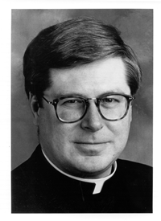
“Thus you shall say to the house of Jacob, and tell the Israelites: You have seen what I did to the Egyptians, and how I bore you on eagles’ wings and brought you to myself” (Exodus 19:4, NRSV).
Many recent composers for the church draw from biblical sources, making allusions to specific images. Father Jan Michael Joncas (b. 1951) uses the providential image of “eagle’s wings” as the anchor metaphor for his widely sung hymn.
In a presentation for the National Association of Pastoral Musicians (NPM) convention in Long Beach in 1989, Joncas stated, “Scripture grounds my life as a Christian, a preacher, and a priest” (Joncas, GIA Publications, Inc. website). “On Eagles’ Wings” is an example of the scriptural content of Fr. Joncas’s compositions. The composition appeared first in the liturgical music collection On Eagles’ Wings in 1979.
The hymn was written in 1978 as Joncas was concluding his MA in liturgy from Notre Dame. He was ordained in 1980 as a priest for the archdiocese of St. Paul/Minneapolis.
This music written for the Catholic liturgy should not be confused with choruses composed by contemporary Christian artists whose roots are in evangelical Christianity. At the National Pastoral Musicians conference in Long Beach, Fr. Joncas noted, “We pastoral musicians do not sing to entertain bored worshipers or to seduce them into brainless ecstasy; we may sing in the Spirit, but we also sing with our minds” (Joncas, GIA Publications, Inc. website).

